HARVARD AIKIKAI
IS PROUD TO PRESENT
OUR ANNUAL SPRING SEMINAR FEATURING:

The INSTRUCTORS of HARVARD AIKIKAI
and

GUEST INSTRUCTOR
FABIEN SORIN
Nidan, MIT Aikido Club

DATE: FRIDAY, APRIL 10th, and SATURDAY, APRIL 11th, 2009

At the Harvard University
QUADRANGLE RECREATIONAL ATHLETIC CENTER (QRAC)

*All Potential Participants must RSVP (to: janng@fas.harvard.edu) by Saturday, April 4th to ensure access to the facility*

Tentative Schedule:

Friday, April 10th:

6:30 pm – 7:00 pm | Registration
7:00 pm – 7:50 pm | Class
8:00 pm – 8:50 pm | Class

Saturday, April 11th:

12:00 pm – 12:30 pm | Registration
12:30 pm – 1:20 pm | Class
1:30 pm – 2:20 pm | Class
2:30 pm – 3:20 pm | Class
3:30 pm – 4:20 pm  5:30 pm – end | Class  Seminar Potluck Dinner
SPRING SEMINAR REGISTRATION FORM

 | Name:
 | Address:
 | City: |  |  |  |  | State: |  |  |  |  | Zip Code:
 | Telephone: |  |  |  | ( ) | E-mail Address:
 | Dojo: |  |  |  |  |  | Rank:
 | Sensei:
SEMINAR FEE: Full seminar:
$50 Adult $40 Students and Children
or best offer

Per Class:
$10 Adult $8 Students and Children
or best offer

Please make checks payable to the “Harvard Aikikai”

Waiver of Liability
I, the undersigned, request the privilege of admission to the Aikido seminar organized by the Harvard Aikido Club, hereinafter called the dojo, and given at the above mentioned place and time. I understand that Aikido is a martial art involving strenuous exercise and physical contact. I further understand that neither the dojo nor the organizers of the seminar offer any insurance or guarantees of any sort, nor subscribe to any insurance against injuries to the seminar participants or damage to their property. In consideration of the privilege of being admitted to participate in the seminar, of receiving the provided instruction and of using the host organization's installations for the duration of the seminar, I hereby declare that I will personally assume all responsibility concerning any injury that I may incur or that may be inflicted on me by others during the seminar, be it on or off the premises, before, after, during or between sessions. I hereby hold immune and release the dojo, its directors, employees, agents and representatives, the organizers of the seminar and the instructors of the seminar from all responsibility, accountability and any reparations concerning personal injuries, lawsuits, damages, or losses of any nature whatsoever, in law or in equity, relative to the activities mentioned above. I hereby agree and engage, in my name and in the name of my heirs and beneficiaries, never to pursue, legally or in equity, the dojo, its directors, employees, agents or representatives, nor the organizers of the seminar nor the instructors of the seminar in relation to such injuries, lawsuits, damages, responsibilities, accountabilities, reparations or losses. TO ATTEST TO THIS, I have signed this document and declare that I have read it and understand it.
Signature: |  | Date:
Signature: |  | Date:
Parent or Guardian if under 18 years old

Seminar Registration:

If anyone from your dojo plans on even possibly attending this seminar, please send a list of names to Jan Ng (janng@fas.harvard.edu) so that no one will be denied entrance to the facility. Harvard carefully monitors the entrance to the building, and may disallow access to anyone who either does not have a Harvard ID or whose name is not on the guest list that Harvard Aikikai will provide to the front desk. The pre-registration deadline is Saturday, April 4th by e-mail (either e-mail the form, or notify us that you are coming and you can fill out a form when you arrive, whichever is more convenient).

The important thing is to PLEASE SUBMIT THE LIST OF POSSIBLE ATTENDEES (those who plan on attending and those who are thinking to do so) BY SATURDAY, APRIL 4TH.

Seminar Logistics:

The seminar will be held in the mat room downstairs at the Quadrangle Recreational Athletic Center (QRAC). Locker rooms (both men’s and women’s) are available right next to the mat room. When entering the QRAC, you will need to check in at the front desk. Please tell them that you are associated with the Aikido Seminar, and give them your name. It would also be good to bring some form of photo identification (a university ID or driver’s license should be fine) to avoid any problems. Lockers will be available in the locker room, and we will have space in the seminar venue for some gear storage. Please bring a combination lock if you plan to use the locker rooms, and please bring your own towel. Lockers are also for day use only, so please take all of your belongings with you at the end of the day.

Day-of registration will be in the seminar venue.

Public Transportation:

Parking around Harvard tends to be very difficult, so we encourage Boston-area residents to use the T. Take the Redline outbound to Alewife, and get off at the Harvard Square or Porter Square T-stops. QRAC is located at 66 Garden Street.

From Harvard Square walk north to Garden Street (the left hand side of Cambridge Common). Walk along Garden Street until you reach the corner of Garden and Linnaean Streets. On your left there will be a long driveway. The building immediately next to the driveway is the QRAC. There will be signs marking the door you should enter.

From Porter Square, walk south towards Harvard Square. When you reach Linnaean Street on your right (Next to Brooks Pharmacy), turn and walk down Linnaean Street until it ends where it meets Garden Street. Across the street you will see a driveway. The QRAC is the building immediately left of the driveway. It is large, brick, and partially buried under a grassy hill.

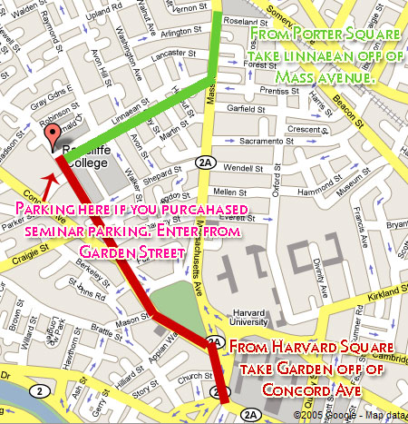

Parking:

Private parking lots are available around the square. Costs for these parking facilities will usually run about $20 a day. There will also be free street parking available just outside of the QRAC on Garden and Linnaean Streets.

Dinner:

The potluck seminar dinner is scheduled to start at 5:30; however, feel free to come any time after 4:45. The club will be covering the cost of some main dishes, but participants are encouraged to bring a dish, side dish, or dessert if possible. Please come anyway even if providing a dish proves difficult! We will also be providing soda, juice, and water for beverages. The directions to the dinner location will be given at the seminar.

Staying Over:

Out-of-town participants are welcome to stay with members of the Harvard Aikikai on a first-come, first-serve basis. Please e-mail club president Jan Ng (janng@fas.harvard.edu) to make arrangements. Some bed and futon space is available; however, participants are highly encouraged to bring a sleeping bag if they plan to stay with a club member overnight.

